

Blockchain Technologies

Lab Record



**NAME :** *RAMEEZ AHMAD*

**ROLL NO :** *20131A4245*

**MAIL ID :** *20131a4245@gvpce.ac.in*

**WEEK-1**

1. **Generate Public private key pairs for Bitcoin and Ethereum addresses.**
2. **Connect to the Public/Test net Ethereum Blockchain network using popular wallets ( MetaMask, Brave browser) and understand various terminologies like gas, gas fee, gas price, priority fee.**

**Procedure :**

* **Download Brave Browser:** Begin by downloading the Brave Browser, a privacy-focused web browser known for its enhanced security features. This browser will serve as the platform for accessing and utilizing the MetaMask extension.
* **Install MetaMask Extension:** Navigate to the official MetaMask website at https://metamask.io/ using the Brave Browser. Download and install the MetaMask Chrome extension from the provided link. This extension enables seamless interaction with Ethereum-based applications and facilitates the creation and management of Ethereum wallets.
* **Create a MetaMask Account:** Upon successful installation of the MetaMask extension, open it and follow the on-screen instructions to set up a MetaMask account. This involves generating a unique password and securely storing it. Once the account is created, a public key is automatically generated, which is essential for receiving Ethereum transactions.
* **Locate Public Key:** After logging in to your MetaMask account, the public key associated with your Ethereum wallet will be visible within the extension window. This public key, represented by a hexadecimal string (e.g., 0x2B9e0CbB6737615f2749fc3638a8bAD048f4977c), is used for receiving cryptocurrency funds and verifying transactions.
* **Access Private Key:** To view the private key of your Ethereum wallet, navigate to the 'Account Details' section within the MetaMask extension. From there, choose the option to 'Show Private Key' and enter your account password for authentication. The private key is a sensitive piece of information that provides full control over the associated Ethereum wallet. Exercise caution and ensure its secure storage.

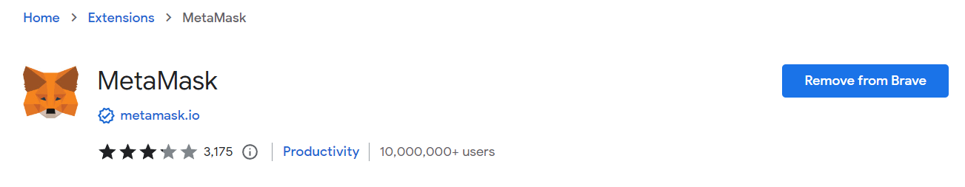

1. **Send test ether from one account to another.**

**Procedure :**

* **Access MetaMask Extension:** Launch the MetaMask extension, which was previously installed as described in the earlier sections of this lab record. Ensure that you are logged into your MetaMask account.
* **Initiate Transaction:** Within the MetaMask interface, locate and select the 'Send' option. This action signifies your intention to initiate an Ethereum transaction.
* **Enter Recipient Address:** In the subsequent window, input the recipient's Ethereum address, also referred to as the public key. This address is the destination for the test ether transfer and ensures that the cryptocurrency reaches the intended recipient.
* **Provide Transaction Details**: Within the following window, provide specific transaction details. This includes specifying the amount of ether to be transferred and setting the gas price. The gas price determines the fee associated with processing the transaction on the Ethereum network.
* **Proceed to Next Step:** Once transaction details are entered accurately, proceed by clicking the 'Next' button. This advances you to the next stage of the transaction process.
* **Confirm Transaction Details:** Review the transaction details presented on the confirmation screen. Ensure that all information, including the recipient address, transaction amount, and gas price, is correct.
* **Confirm Transaction:** With confidence in the accuracy of the provided details, click on the 'Confirm' button. This action confirms your intent to execute the Ethereum transaction.
* **Finalize Transaction:** MetaMask will initiate the transaction process, broadcasting it to the Ethereum network. Wait for the network to process the transaction. A confirmation notification will indicate the successful transfer of the test ether.

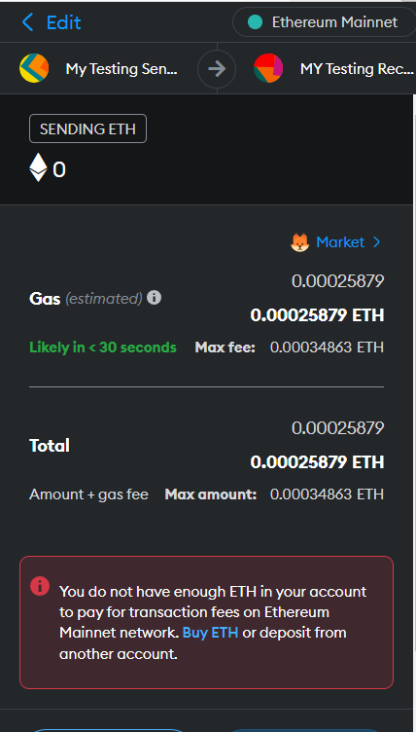

**WEEK-2**

**Installation and Configuration of Node.js and Web3.js**

**Procedure :**

* **Install Node.js:** Download and install Node.js from https://nodejs.org/.
* **Open Terminal:** Access your terminal or command prompt.
* **Install Web3.js:** Run npm install web3 to install the Web3.js library.
* **Create File:** Create a JavaScript file, e.g., ethereum.js, in a text editor.
* **Initialize Web3.js:** In ethereum.js, use const Web3 = require('web3'); const web3 = new Web3('YOUR_NODE_URL'); to set up Web3.js.
* **Interact with Ethereum:** Write code to interact with Ethereum, like web3.eth.getBlockNumber().then(blockNumber => console.log('Block:', blockNumber));.
* **Save File:** Save ethereum.js.
* **Terminal:** Navigate to the file's directory in the terminal.
* **Run Script:** Execute node ethereum.js to run the script.
* **Explore Ethereum:** Your script now interacts with Ethereum using Node.js and Web3.js.

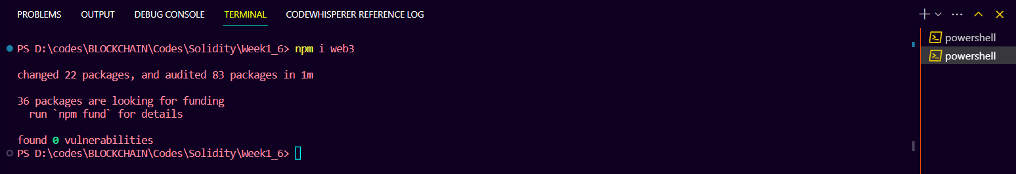

**WEEK–3**

**Using Web3.js to Transfer Ether from one account to another .**

**Code:**

const { Web3 } = require("web3");

const web3 = new Web3("HTTP://127.0.0.1:7545");

*// Private key of the sender's Ethereum account*

const senderPrivateKey =

    "0x28c5f4f67ed61e5ef7c6c712b9e6b62deb94dd5f3684b27b81e9d3883a04206f";

*// Sender's Ethereum address*

const senderAddress = "0xD2D473Ac80Df9c59B7F8817920Ee8D06e1a6f581";

*// Recipient's Ethereum address*

const recipientAddress = "0x0474c3D5241D703f573F764A0Ee94A335e582e01";

*// Replace with the recipient"s Ethereum address*

*// Transfer Ether function*

async function transferEther() {

*// Get the current gas price*

    const gasPrice = await web3.eth.getGasPrice();

*// Estimate the gas required for the transaction*

    const gasEstimate = await web3.eth.estimateGas({

        from: senderAddress,

        to: recipientAddress,

        value: web3.utils.toWei("0.1", "ether"), *// Amount of Ether to send (in this example, 0.1 Ether)*

    });

*// Create the raw transaction object*

    const rawTx = {

        from: senderAddress,

        to: recipientAddress,

        value: web3.utils.toHex(web3.utils.toWei("0.1", "ether")), *// Amount of*

*// Ether to send, converted to Wei*

        gasPrice: web3.utils.toHex(gasPrice),

        gasLimit: web3.utils.toHex(gasEstimate),

    };

*// Sign the transaction with the sender"s private key*

    const signedTx = await web3.eth.accounts.signTransaction(

        rawTx,

        senderPrivateKey

    );

*// Send the signed transaction to the Ethereum network*

    const txReceipt = await web3.eth.sendSignedTransaction(

        signedTx.rawTransaction

    );

    console.log(

        "Transaction successful. Transaction hash:",

        txReceipt.transactionHash

    );

}

*// Call the transferEther function to initiate the transaction*

transferEther();

**Output :**

NOTE: web3.js is running without provider. You need to pass a provider in order to interact with the network!

d:\codes\BLOCKCHAIN\Codes\Solidity\Week1_6\node_modules\web3-eth\lib\commonjs\utils\get_transaction_error.js:48

error = new web3_errors_1.TransactionRevertInstructionError(_reason, undefined, transactionReceiptFormatted);

TransactionRevertInstructionError: Transaction has been reverted by the EVM

at d:\codes\BLOCKCHAIN\Codes\Solidity\Week1_6\node_modules\web3-eth\lib\commonjs\utils\get_transaction_error.js:48:21

at Generator.next (<anonymous>)

at d:\codes\BLOCKCHAIN\Codes\Solidity\Week1_6\node_modules\web3-eth\lib\commonjs\utils\get_transaction_error.js:24:71

at new Promise (<anonymous>)

at __awaiter (d:\codes\BLOCKCHAIN\Codes\Solidity\Week1_6\node_modules\web3-eth\lib\commonjs\utils\get_transaction_error.js:20:12)

at getTransactionError (d:\codes\BLOCKCHAIN\Codes\Solidity\Week1_6\node_modules\web3-eth\lib\commonjs\utils\get_transaction_error.js:33:12)

at Object.<anonymous> (d:\codes\BLOCKCHAIN\Codes\Solidity\Week1_6\node_modules\web3-eth\lib\commonjs\rpc_method_wrappers.js:441:100)

at Generator.next (<anonymous>)

at fulfilled (d:\codes\BLOCKCHAIN\Codes\Solidity\Week1_6\node_modules\web3-eth\lib\commonjs\rpc_method_wrappers.js:21:58)

at process.processTicksAndRejections (node:internal/process/task_queues:95:5) {

innerError: undefined,

reason: 'VM Exception while processing transaction: insufficient balance',

signature: undefined,

receipt: undefined,

data: undefined,

code: 402

}

Node.js v18.16.0

**WEEK-4**

**Create a Private Ethereum Blockchain network.**

**Procedure :**

* **Install Ganache:** Download and install Ganache from https://www.trufflesuite.com/ganache.
* **Open Ganache:** Launch Ganache and note the local blockchain URL (e.g., http://127.0.0.1:7545).
* **Create File:** Open a text editor and create transfer.js.
* **Install Web3.js:** In the terminal, navigate to the file's directory and run npm install web3.
* **Write Transfer Code:** In transfer.js, use Web3.js to transfer Ether.
* **Run Script:** In the terminal, navigate to the directory and run node transfer.js.
* **Transaction Execution:** Observe the transaction hash output.

const {Web3} = require('web3');

const web3 = new Web3('http://127.0.0.1:7545'); *// Ganache default URL*

async function sendEther() {

    try {

        const accounts = await web3.eth.getAccounts();

        const sender = accounts[0];

        const receiver = accounts[1];

        const amountToSend = web3.utils.toWei('1', 'ether'); *// Convert 1 Ether to Wei*

        const tx = {

            from: sender,

            to: receiver,

            value: amountToSend

        };

        const transactionHash = await web3.eth.sendTransaction(tx);

        console.log(`Transaction successful. Transaction hash: ${transactionHash}`);

    } catch (error) {

        console.error(`Error sending transaction: ${error}`);

    }

}

sendEther();

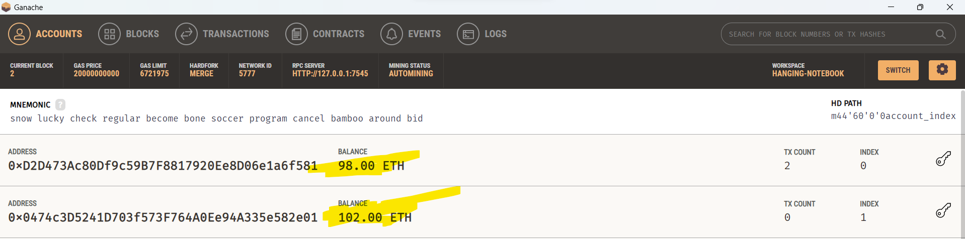**Output :**

**WEEK-9**

1. **Write a program to display the statements.**

**Code:**

fn main() {

*// Print a single line statement*

    println!("Hello, world!");

*// Print multiple statements*

    println!("This is a Rust program.");

    println!("It demonstrates printing statements.");

}

**Output:**

Hello, world!

This is a Rust program.

It demonstrates printing statements.

1. **Write a program to demonstrate the basic data types in Rust.**

**Code:**

fn main() {

    let integer: i32 = 42;

    let float: f32 = 3.14;

    let character: char = 'A';

    let boolean: bool = true;

    let name: &str = "Rameez"; *// Use &str for string literals*

    println!("Integer: {}", integer);

    println!("Float: {}", float);

    println!("Character: {}", character);

    println!("Boolean: {}", boolean);

    println!("Name: {}", name); *// Corrected the println! format string*

}

**Output:**

Integer: 42

Float: 3.14

Character: A

Boolean: true

Name: Rameez

1. **Write a program to format strings and numbers.**

**Code:**

fn main() {

    let integer: i32 = 42;

    let float: f64 = 3.14159265;

    let character: char = 'A';

    let boolean: bool = true;

*// Format integer with leading zeros and specify minimum width*

    println!("Integer (with leading zeros and width 5): {:05}", integer);

*// Format float with precision*

    println!("Float (with precision 2): {:.2}", float);

*// Format character as is*

    println!("Character: {}", character);

*// Format boolean as lowercase*

    println!("Boolean (in lowercase): {:?}", boolean);

    println!(

        "Integer: {:05}, Float: {:.2}, Character: {}, Boolean: {}",

        integer, float, character, boolean

    );

    let my_string = "Hello, Rust!";

*// Using indexing*

    let slice = &my_string[0..5]; *// Slice from index 0 (inclusive) to 5 (exclusive)*

    println!("Slice: {}", slice);

*// You can also omit the start index*

    let slice_from_start = &my_string[..5]; *// Slice from the beginning to 5 (exclusive)*

    println!("Slice from start: {}", slice_from_start);

*// Omitting the end index slices to the end*

    let slice_to_end = &my_string[7..]; *// Slice from index 7 (inclusive) to the end*

    println!("Slice to end: {}", slice_to_end);

}

fn again() {

*// Format a string with placeholders*

    let name = "Alice";

    let age = 30;

    let formatted_string = format!("Hello, {}! You are {} years old.", name, age);

    println!("{}", formatted_string);

*// Format numbers*

    let pi = 3.14159265;

    let formatted_float = format!("Pi: {:.2}", pi); *// Format as a floating-point number with 2 decimal places*

    println!("{}", formatted_float);

    let number = 42;

    let formatted_binary = format!("Binary: {:b}", number); *// Format as binary*

    let formatted_hex = format!("Hexadecimal: {:x}", number); *// Format as hexadecimal*

    println!("{}", formatted_binary);

    println!("{}", formatted_hex);

}

**Output:**

Integer (with leading zeros and width 5): 00042

Float (with precision 2): 3.14

Character: A

Boolean (in lowercase): true

Integer: 00042, Float: 3.14, Character: A, Boolean: true

Slice: Hello

Slice from start: Hello

Slice to end: Rust!

1. **Write a program to compute arithmetic operations taking input from the user and display the result.**

**Code:**

use std::io;

fn main() {

    println!("Enter two numbers: ");

    let mut input = String::new();

    io::stdin().read_line(&mut input).expect("Failed to read line");

    let numbers: Vec<i32> = input

        .split_whitespace()

        .map(|num| num.parse().unwrap())

        .collect();

    let sum = numbers[0] + numbers[1];

    let difference = numbers[0] - numbers[1];

    let product = numbers[0] * numbers[1];

    let quotient = numbers[0] as f64 / numbers[1] as f64;

    println!("Sum: {}", sum);

    println!("Difference: {}", difference);

    println!("Product: {}", product);

    println!("Quotient: {:.2}", quotient);

}

**Output:**

Enter two numbers:

12 12

Sum: 24

Difference: 0

Product: 144

Quotient: 1.00

1. **Write a program to demonstrate bitwise and logical operators.**

**Code:**

fn main() {

    let a = 0b1010; *// Binary representation of 10*

    let b = 0b1100; *// Binary representation of 12*

    let bitwise_and = a & b;

    let bitwise_or = a | b;

    let bitwise_xor = a ^ b;

    let logical_and = a > 0 && b > 0;

    let logical_or = a > 0 || b > 0;

    println!("Bitwise AND: {:04b}", bitwise_and);

    println!("Bitwise OR: {:04b}", bitwise_or);

    println!("Bitwise XOR: {:04b}", bitwise_xor);

    println!("Logical AND: {}", logical_and);

    println!("Logical OR: {}", logical_or);

}

**Output:**

Bitwise AND: 1000

Bitwise OR: 1110

Bitwise XOR: 0110

Logical AND: true

Logical OR: true

1. **Write a program to swap two numbers without using a temporary variable.**

**Code:**

fn main() {

    let mut num1 = 5;

    let mut num2 = 10;

    println!("Before swapping: num1 = {}, num2 = {}", num1, num2);

    num1 = num1 + num2;

    num2 = num1 - num2;

    num1 = num1 - num2;

    println!("After swapping: num1 = {}, num2 = {}", num1, num2);

}

**Output:**

Before swapping: num1 = 5, num2 = 10

After swapping: num1 = 10, num2 = 5

**WEEK-10**

**Write programs that demonstrate the Compound Data Types in Rust (Arrays, Tuples)**

**Code:**

fn main() {

*// Arrays*

    let numbers: [i32; 5] = [1, 2, 3, 4, 5];

*// Tuples*

    let person: (String, i32, f64) = ("Alice".to_string(), 25, 5.8);

    println!("Array: {:?}", numbers);

    println!("Tuple: {:?}", person);

}

**Output:**

Array: [1, 2, 3, 4, 5]

Tuple: ("Alice", 25, 5.8)

**WEEK-11**

**Write programs that can demonstrate the working of loops and Conditional Loops in Rust**

**Code:**

fn main() {

*// For loop*

    for i in 1..=5 {

        println!("For loop: {}", i);

    }

*// While loop*

    let mut counter = 0;

    while counter < 5 {

        println!("While loop: {}", counter);

        counter += 1;

    }

*// Conditional loop (loop with break)*

    let mut value = 0;

    loop {

        println!("Value: {}", value);

        if value >= 5 {

            break;

        }

        value += 1;

    }

}

**Output:**

For loop: 1

For loop: 2

For loop: 3

For loop: 4

For loop: 5

While loop: 0

While loop: 1

While loop: 2

While loop: 3

While loop: 4

Value: 0

Value: 1

Value: 2

Value: 3

Value: 4

Value: 5

**WEEK-12**

**Write a program that can demonstrate**

**A)Assigning value of one variable to another variable.**

**B)Passing value to a function.**

**C)Returning value from a function.**

**Code:**

*// Function that returns the square of a number*

fn square(x: i32) -> i32 {

    return x * x

}

fn main() {

*// Assigning value of one variable to another*

    let num1 = 5;

    let num2 = num1;

*// Passing value to a function*

    let result = square(num2);

*// Returning value from a function*

    println!("Square of {} is {}", num2, result);

}

**Output:**

Square of 5 is 25

**WEEK-13**

**Write a program to generate a Random number using Rust**

**Code:**

use rand::Rng;

use std::io;

fn week_13() {

    let random_number = rand::thread_rng().gen_range(1..=100);

    println!("Random number: {}", random_number);

}

fn main() {

    week_13();

}

**Output:**

Random number: 37

**WEEK-14**

**Write a program that can compare the guessed number with a Secret generated number**

**Code:**

use rand::Rng;

use std::io;

fn week_14() {

    let secret_number = rand::thread_rng().gen_range(1..=100);

    loop {

        println!("Guess the number (1-100): ");

        let mut guess = String::new();

        io::stdin().read_line(&mut guess).expect("Failed to read line");

        let guess: i32 = match guess.trim().parse() {

            Ok(num) => num,

            Err(_) => {

                println!("Please enter a valid number.");

                continue;

            }

        };

        if guess == secret_number {

            println!("Congratulations! You guessed the number.");

            break;

        } else if guess < secret_number {

            println!("Try a higher number.");

        } else {

            println!("Try a lower number.");

        }

    }

}

fn main() {

    week_14();

}

**Output:**

Guess the number (1-100):

50

Try a lower number.

Guess the number (1-100):

25

Try a higher number.

Guess the number (1-100):

37

Try a higher number.

Guess the number (1-100):

45

Try a lower number.

Guess the number (1-100):

40

Try a lower number.

Guess the number (1-100):

38

Congratulations! You guessed the number.